Workshop on CEG and social justice

By Kristin Midttun, kristinmidttun@hotmail.com

- Workshop outline: p 2

- Learning objectives and learning evidence: p 9

- Summaries and exercises: p11

Workshop sections

Overview:
Workshop sections
Section 1 | Introduction
Section 2 | Perspectives on justice:  Introduction, application and review of four different perspectives according to Irving
Section 3 | CEG’s socio-political roles:  Introduction, application and review of Watts’ four approaches
Section 4 | A pedagogy for enactment:  Introduction and review of one session outline from Simon et al.’s critical pedagogy
Section 5 | Enactment in County Career Centre context:  Review own practices, explore enactment and form responses
Section 6 | Feedback on the workshop:  Suggestions for further development  Closure

Sections in detail
Workshop section 1
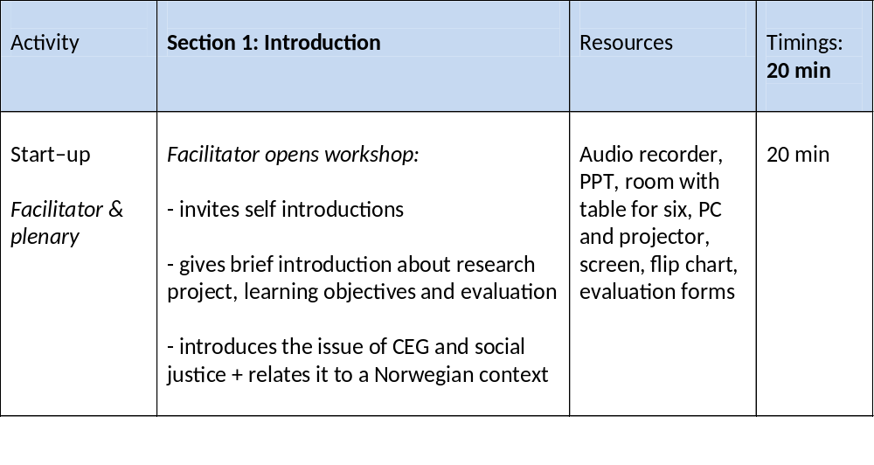
Workshop section 2
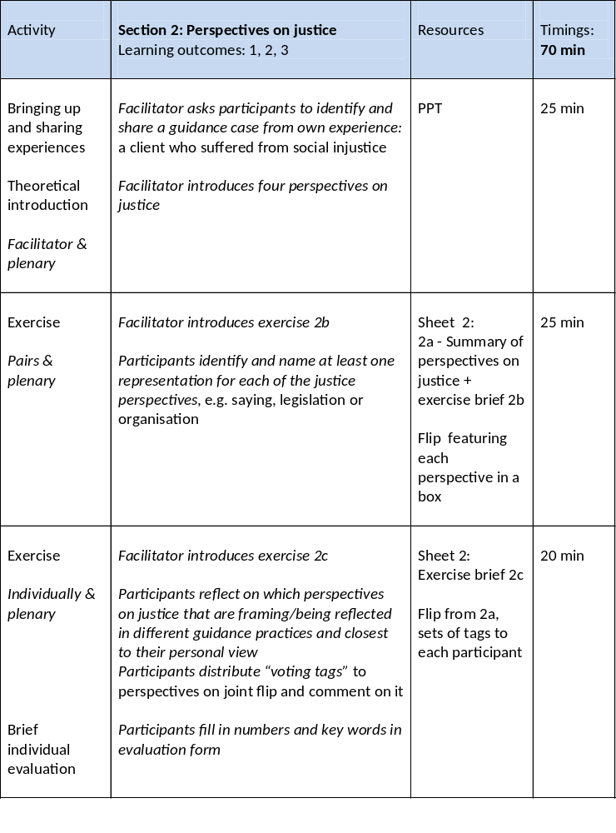
Workshop section 3
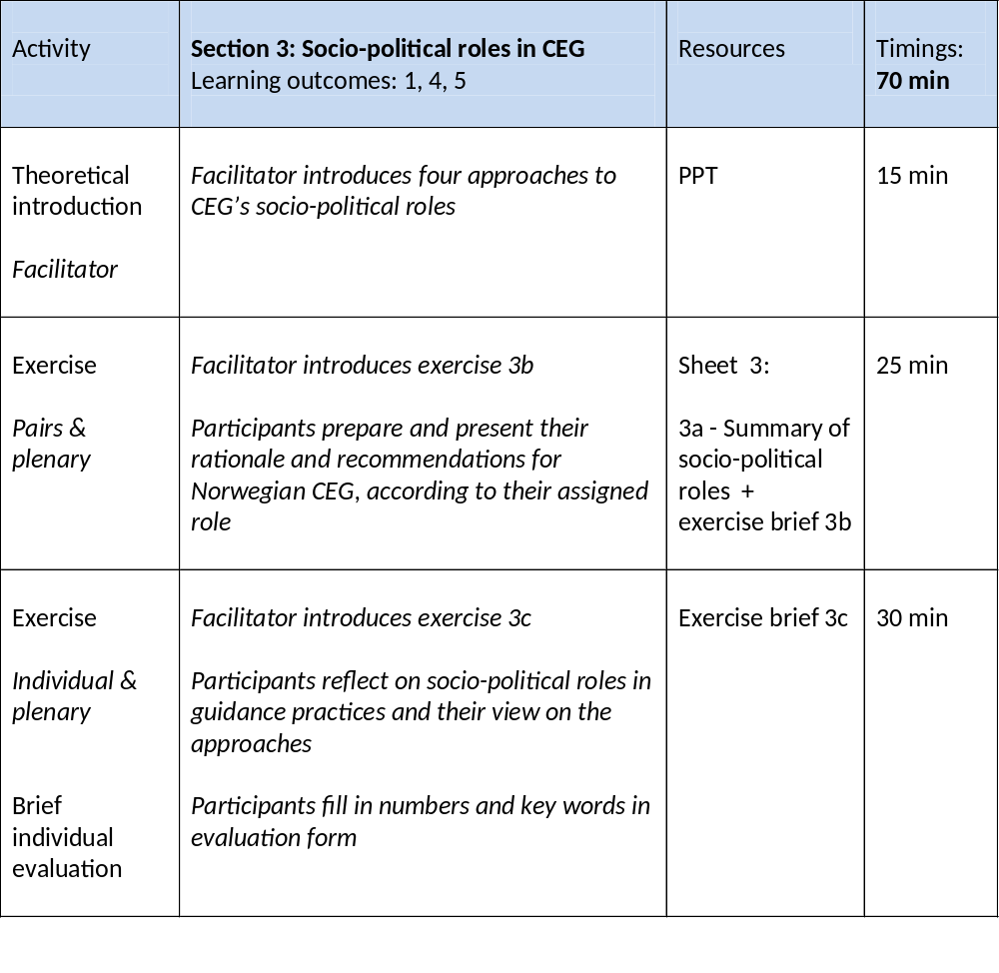

Workshop section 4
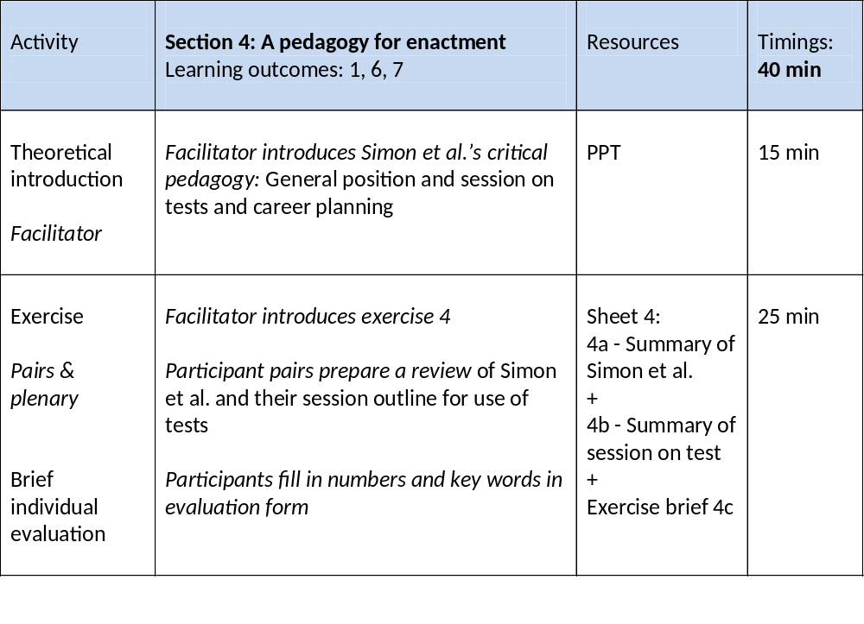

Workshop section 5
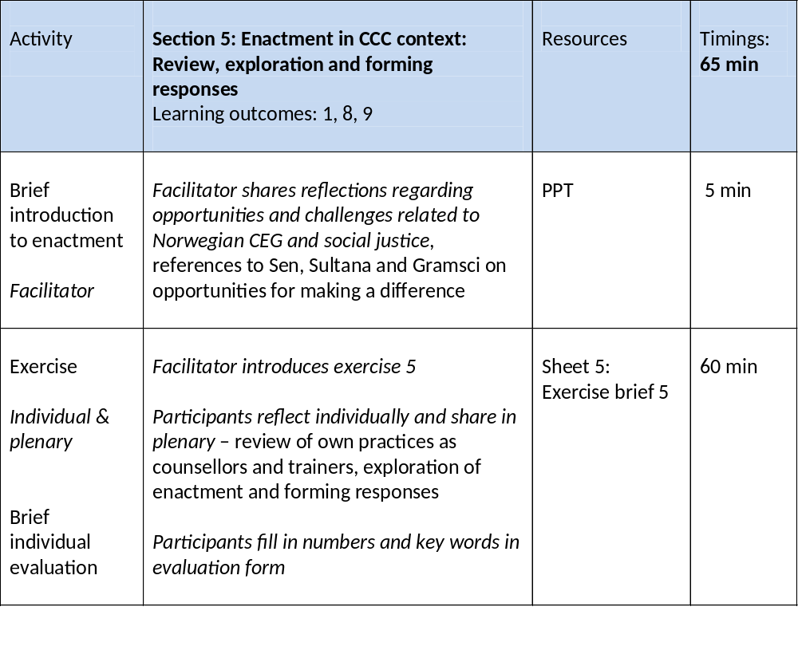

Workshop section 6
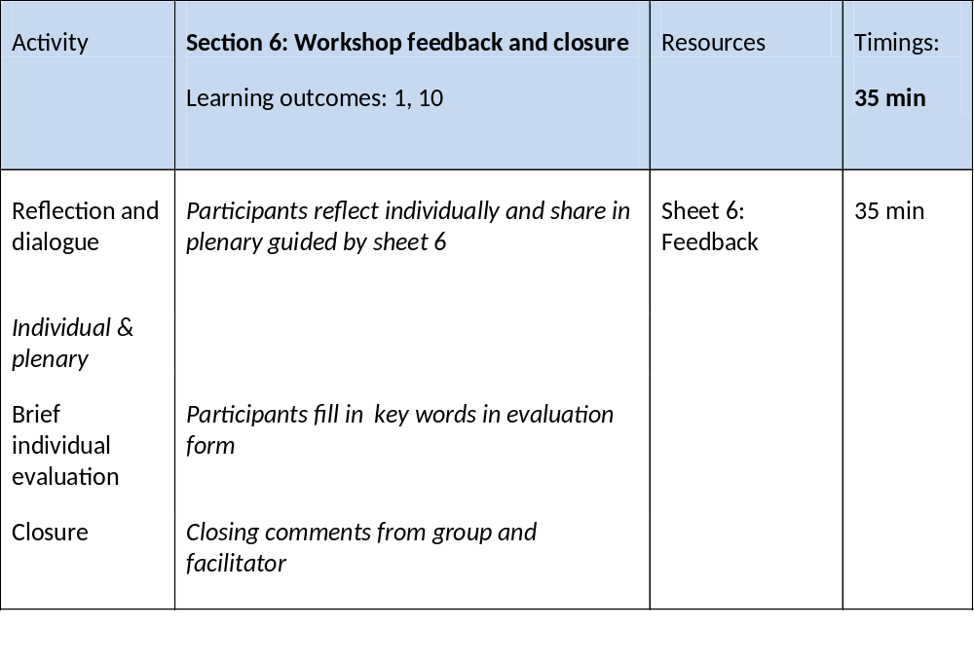

Learning outcomes and corresponding learning evidence

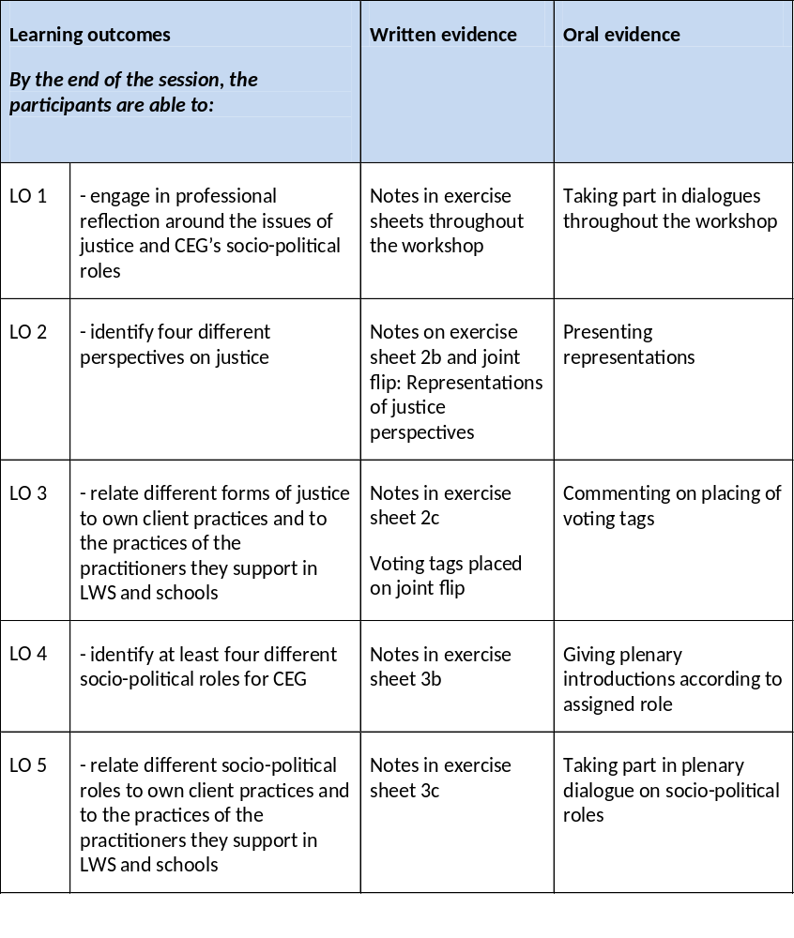

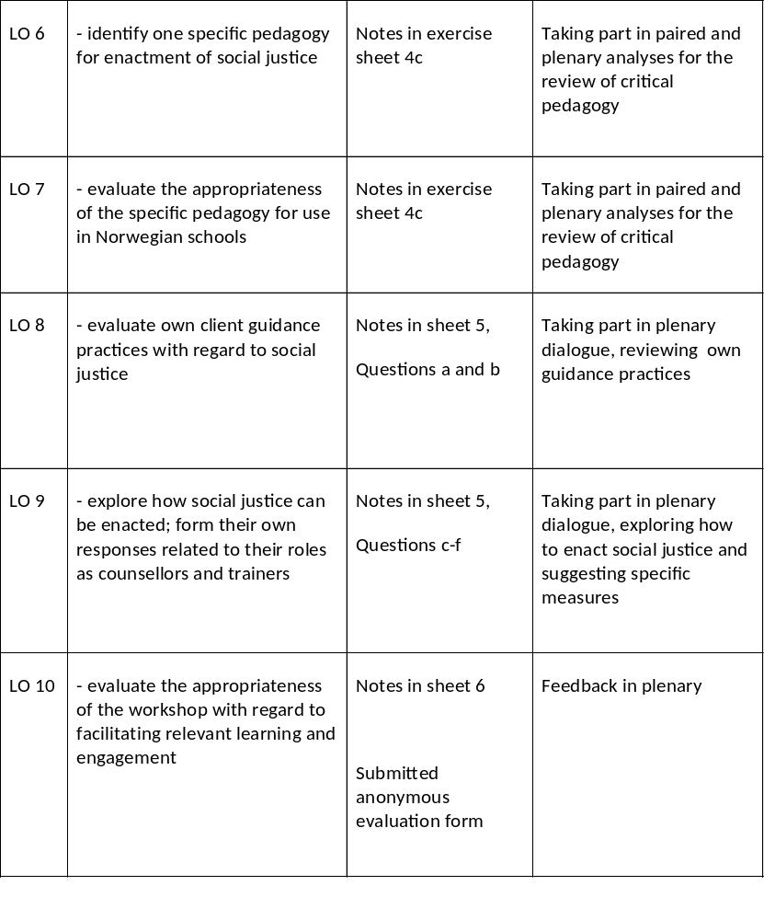

Summaries and exercises

Workshop on CEG and social justice

Sheet no 2

2a Summary: Four perspectives on justice (Irving 2010, 2014)
Perspective and related “career” concept | Justice defined,  What is the objective, what characterises a just society? | How should social justice be achieved? | Who should social justice benefit?
Retributive  “Career” is construed as being of our own making, influenced by individual drive, determination and latent talents – we make our own ‘luck’ | - Material and social goods/opportunities commensurate with talent and effort | - Through open competition and (government) protection of life and property | - Individuals who contribute (economically) to society
Redistributive  “Career” is constructed by the individual, accommodates other life roles and desires, but is construed primarily as an economic concept | - Material and social goods/opportunities basic to social life | - Mixed economy  - Proportional distribution to individuals/groups  - Those who do not secure their own income receive basic support – at least for a period of time | - Dis-advantaged individuals/  Groups
Recognitive  “Career” is constructed in relation to the desires of self, family and community, and may not include economic participation | - Positive self-identity,  self-development and  self-determination for all  - Diversity is valued | - Through democratic processes that include the interests of the least advantaged  - Equitable distribution of goods not driven by labour market participation | - All people; differently experienced among and within different social groups
Critical social justice –  “Career” is constructed as holistic, and it is recognised that it is always in a state of flux and can take multiple forms – including those that might challenge the state | As in recognitive plus:  - Real participative democracy - Positively accommodates the views and desires of diverse groups  - Positive recognition of diversity and differences  - A valuing of all for who they are, and for their social contribution, not their economical contribution | - Fostering a critical political citizenship,  cultivating dialogue and a culture for internal and external critique of own and others’ practices  - Equality in recognition and the equitable distribution of goods | - All people; differently experienced among and within different social groups

Exercise 2b: Finding representations – perspectives on justice

What representations can you think of that could be related to each of the four perspectives?
Perspective | Representations (e.g. organisations, individuals, statements, commercials, sayings, stories, religious texts, song lyrics…)
Retributive
Distributive

Recognitive
Critical social justice

10 minutes in pairs, 10 minutes presentations/dialogue

Exercise 2c: Relating perspectives on justice to guidance practices

- What perspectives on justice would you say are framing or being reflected in the public career guidance services you are involved in? Exemplify/give reasons.

- What perspective(s) on justice are closest to your personal perspective? Elaborate…

- You have been given two differently coloured sets of tags representing your professional CEG context and yourself. Each set contains three tags. Distribute the tags on the perspectives on justice flips according to what perspective(s) you find reflected in/framing the practices in your professional context, and your personal views. You can place all three tags onto the same form of justice, or split them up if you think several forms are represented within one field of practice/your personal views.

12 minutes individual reflection and placing of tags, 10 minutes sharing in plenary

Sheet 3

3a Summary: Watts’ approaches to CEG’s socio-political ideologies/roles

 | Core focus on society | Core focus on individual
Change | Radical - social change  For everyone to have a good career society must change. Not sufficient to help individuals progress= ”shuffling of the cards”  Might involve making individuals see their challenges as group challenges, rather than individual challenges  Counsellor role: advocacy; fighting alongside and for unprivileged, to change structures in order to increase justice and opportunities for all  Example: challenge educational systems/local school practices that push students out | Progressive - individual change  Extend horizons of opportunity, raise aspirations  Empowerment, assertiveness training  Use of role models  Support to progress  Counsellor role: pro-active  Example: support women in advancing to leading positions
Status quo | Conservative - social control  Sociologically inspired, function of guidance - might be different from intention  Guidance on the basis of the needs of the labour market, emphasis on ”being realistic”  Social inequality is masked in a language of individual choice and the dignity of work  Counsellor role: assist individuals in adapting to the needs of the labour market, “gatekeeper”  Example: highly qualified immigrants who are encouraged to reduce their ambitions in order to achieve a job | Liberal - non-directive  Inspired by Carl Rogers  Assist individuals in making career choices according to their abilities, skills, interests and values  Different values and interests means it is possible to ”win” in different ways  Counsellor role: facilitative  Example: guidance according to the client’s values – which might reproduce systematic differences, e.g. dominance of women in care work

Exercise 3b:

Representing socio-political roles in a plenary debate on CEG’s roles. What should be CEG’s contributions?

You/your group will be assigned one of the four roles (liberal, progressive, conservative or radical) which you are asked to act out in a plenary debate. Feel free to exaggerate slightly, have fun.
- Prepare to deliver two 1-minute introductions by answering the following questions according to you assigned role,
  - What should be CEG’s contributions be in your country, what is the point of having a public CEG provision? Exemplify.
  - What should we do more of within CEG? What should we stop doing?
The facilitator can be called on for assistance in the preparations.

- Delivery of your introductions. The facilitator will ask all participants/groups to deliver their first introduction. Feel free to relate your arguments to the previous introductions. When all participants/groups have delivered the first introduction, you will be asked to proceed with the second one.

10 minutes individual preparations, 10 minutes in plenary

Exercise 3c:

Reflecting on socio-political roles/ideologies in guidance practices

- Which role(s) would you say is most strongly reflected in your CEG context?

- Do you buy into this set of approaches, or do you have objections to it?

Individual reflection 10 minutes, plenary dialogue 17 minutes

Sheet no 4

4a Summary of Simon et al.‘s critical pedagogy, “Learning Work”
(Simon et al., Mc Cash)

Objective: “to enhance the ability of students to increase their effective participation in determining the practices that define their working lives” (p. 8).
Simon et al. sought to
- - raise the students’ awareness that that work is socially and politically constructed
- - problematise experience and taken for granted understandings about society and ourselves “Pedagogy of possibility”, nurture hope.
- - encourage questioning, debate and critique - facilitate a respectful and safe learning environment in which divergent views can be articulated and examined Education is not about transmission of truths from teachers to students, but about enabling the students to think for themselves.
- - counter what was seen as an over-individualising tendency in some career development programmes - encourage cooperation and joint solutions rather than competition

4b Example sessions - Career planning and tests

Aim: To facilitate the participants’ development of a perspective on how to use vocational tests in the context of career planning (pp.154-8).

Part 1: Test-taking and discussion
- The facilitator picks two standard occupational inventories for the class to use, e.g. the interest explorer on www.vilbli.no, Vip 24 and WIE.
- When the participants have completed the test, the facilitator asks the group to share their thoughts and consider some questions, for example:
How did the test make you feel?
Any contradictory questions?
Any differences between male and female responses?
Any items that did not make sense to you?
Any differences between the two tests?
Any thoughts on the suitability of the listed jobs?
Part 2: Field survey
Students are asked to assess the degree to which people follow a systematic, rational procedure in choosing their jobs or careers.
- Assignment: students are asked to interview two people in work life to obtain information about how they chose their particular line of work. To do this the class is invited to design some questions, such as:
Can you tell me how you came to be working as an X at Y workplace?
What seemed most important at the time you were making these decisions?
What alternatives were available?
- Once the interviews are complete, the class is invited to compile this information, using
posters, so that all members of the class can consider the survey results.

Part 3: Class debate
- Together the class should consider the following questions:
What factors influenced the respondents’ choices?
Were the choices largely the result of rational planning and deliberation, or a result of circumstance or luck?
Would a more systematic approach to career planning have been of any use to the people surveyed?
How were their decisions affected by things that happened outside their life at work?
- Finally, each participant should (then) be asked to assess the value of test-taking in career development.

Summary of session outline

- Despite possible concerns about testing, the participants are encouraged to encounter the test in order that they can adjudicate it partly on the basis of this personal experience.
- The session is structured in order to enable the participants to question everyday realities about testing. Simon et al. do not assume that people will be able to do this without assistance.
- There are structured questions for the participants to consider in all three parts of the activity.
- There is a sharing of results so that all participants can benefit from the field visits each has undertaken.

Exercise 4c: Prepare a review of Simon et al. for a school career counsellor journal

- Prepare a review of Simon et al.’s general approach and outline for a session on tests and career development
- Imagine the review is for a journal for school career counsellors
- You are not going to write the review, just start working on it by considering strengths and weaknesses, using the table below
- Contrast this approach with ”traditional” test sessions in which the tests are used exclusively to explore, reflect and name personal interests and characteristics
- It does not matter if you do not get to do a full analysis – just start noting some points on strengths and weaknesses to discuss in plenary
- Work in pairs for 10 minutes, further reflection and sharing in plenary for 15 minutes

Strengths
Weaknesses
Further comments

Sheet no 5

Exercise 5:

Reviewing practice, exploring enactment and forming responses

- What are the strengths of your client practices with regard to social justice?

- What are the weaknesses of your client practices with regard to social justice?

- If you were to strengthen your practices with regard to social justice, how could it be done? Be specific!

- Following these reflections: are there two specific ideas that you would like to trial out?

20 minutes individual reflections, 40 minutes plenary dialogue

